**CloudScape for Cloud Operating Program**

**This repository is accessible to all users in the github.com/equinor organization. Please do not expose any classified (i.e. restricted or confidential) information in the architecture contract or any other files in this repository. For guidance use IT governance, for TDI projects use R&T governance.**

* **Leading advisor** (primary contact): Keth Iren Braut
* **EITA architect** (primary contact): ?
* **Lead developer/developer contact**: ?/ Mubashar Hussain
* **Git repository**: [https://github.com/equinor/<TBA](https://github.com/equinor/%3cTBA)>

[**Project and Leading Advisors Summary**](https://acrepo.azurewebsites.net/#/template/ac_template?id=project-and-leading-advisors-summary)

Use R for recommend or NR for Not Recommended to visualize the "state" of the issues raised.

| **Responsible** | **Content** | **Result (Recommend-R or Not Recommended-NR)** | **Comments** |
| --- | --- | --- | --- |
| EITA | Aligned with BA strategy | Blank | Comments here |
| EITA | Aligned with (or develop) TO-BE architecture for the area | Blank | Comments here |
| Leading advisors | Comply with technical direction | Blank | Comments here |
| Leading advisors | IT Technology | Blank | Comments here |
| Leading advisors | Information Management | Blank | Comments here |

[**Meeting log**](https://acrepo.azurewebsites.net/#/template/ac_template?id=meeting-log)

* 27.07.2020 – Initial meeting with leading advisor to review the Architecture Document

Name of Participants: Keth, Mubashar, Pradeep and Nupur

* DD.MM.YYYY - Document participants and type of meeting.

[**Discussions & Actions**](https://acrepo.azurewebsites.net/#/template/ac_template?id=discussions-amp-actions)

Please document discussion from meetings. Address the topic and what was discussed / commented. E.g. Area / Topic and Comments.

* Reviewed the draft document
* Keth highlighted the areas, where more clarity is needed and links to be added
* Planned the steps ahead



[**Self-assessment questions**](https://acrepo.azurewebsites.net/#/template/ac_template?id=self-assessment-questions)

The below is a non-exhaustive list of topics to be discussed during the architecture contract meetings. These are intended as triggers for self-assessment and discussion and might not contain all relevant topics or questions. Feel free to supplement as necessary. Additionally not all questions and topics will be relevant for all types of solutions / architecture contracts.

Answer based on the current state of the software / activity. Try to answer all questions. If you have not decided on a particular subject or think a question is not relevant, please state so (e.g. "Not decided yet", or "Not relevant because ...").

Based on the discussion, the architecture contract will be updated to contain specific points or issues that the project should follow up on, improve on or seek help on.

[**General**](https://acrepo.azurewebsites.net/#/template/ac_template?id=general)

* Which business area is the solution meant for? (use full name rather than abbreviation for business area/unit).

Global Business Services- Information Technology (GBS-IT), Dag Ove is the product owner

* Who are the users?

Mubashar Hussain, Nupur Biswas and Gangadhar G from HCL COP Team

* Application description (brief)

Cloudscape is an agent-less turnkey cloud assessment solution designed to simplify the planning and execution of cloud migration. Data is collected by the RN150 (On-prem VM) at the client location and periodically exported, encrypted, and securely transmitted via TLS to the RISC Networks Secure Cloud Environment (SCE) which is the data repository for the engagement. The data is then accessed by browsing to [www.riscnetworks.com](http://www.riscnetworks.com) and logging in to the assessment portal.

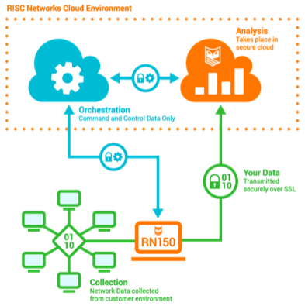

* Main technologies (programming languages, frameworks, run-time environments etc.)

CentOS/Linux (2.6 Linux Kernel) Virtual Appliance

* Where will the software be hosted?

Deployed on on-prem VMware ESX or ESXi Server (Hardware Ver. 8), VMware Player, or VMware Workstation

* Link to architecture diagrams (preferably C4 Model for software architecture)

<https://documentation.riscnetworks.com/overview/architecture%252C-data-handling%252C-and-security/>



* How has EITA been involved in ensuring alignment with the strategy for the business area?

Cloudscape has been reviewed by Matthew Smith, Morten Carlsen, Kare Norgen, Jon Ole Nome, Petter Wersland, Jørgen Moum and Morten Somby and approved for deployment.



[**Software Development & Software Architecture**](https://acrepo.azurewebsites.net/#/template/ac_template?id=software-development-amp-software-architecture)

* Does the software use any technology components not registered as Now/green (or not listed at all) in [IT Technology Lifecycle](https://techlifecycle.equinor.com/)? If yes, please list them. Does the application expose relevant data/functionality only using approved API mechanisms, as listed in [IT Technology Lifecycle](https://techlifecycle.equinor.com/)?

This is a Linux based Appliance preconfigured and pre-built.

* If you are exposing APIs, have you adapted to the principles in the Equinor [API Strategy](https://github.com/equinor/api-strategy)?

No API’s

* Is the software subject to export control?

No

* TR1621, 2.8.1: *"All software developed by/for Equinor shall be made opensource, unless IP rights prevents this or there are unacceptable risks."* Have you made your software open source? If not, please explain why.

This is an appliance used for discovery provided by a 3rd party vendor

* If you are considering buying (or already have bought) software tools, frameworks, libraries; Have you evaluated open source alternatives?

The evaluation of Cloudscape tool has been done along with Microsoft and it was found to be the best fit tool for the Equinor IT environment keeping in mind the target cloud platform- Microsoft Azure.

If you are considering consuming services based on proprietary software; Have you evaluated alternative services based on open source software?

Yes, they are not a good fit for the Equinor IT environment

* Have all team members participated on software developer onboarding within the last 12 months?

YES

* Does the team follow a documented Software Development Lifecycle Process? Describe very briefly.

As Cloudscape is a pre-configured tool, vendor will be in-charge for the Software development lifecycle process.

<https://documentation.riscnetworks.com/getting-started/quick-start-guide/>

* Do you do auditable code reviews for at least the major/central parts of the code?

No Code to review

* Do you deliver your software in iterations, with short feedback loops?

No, it is a procured tool. The software does not have any iterations, it is just how we use the software for delivering the reports that will be done in iterations. Data is collected by the RN150 (On-prem VM) at the IT environment of Equinor and periodically exported, encrypted, and securely transmitted via TLS to the RISC Networks Secure Cloud Environment (SCE) which is the data repository for the engagement. The data is then accessed by browsing to [www.riscnetworks.com](http://www.riscnetworks.com) and logging in to the assessment portal. PFB the Process Flow Chart for reference:

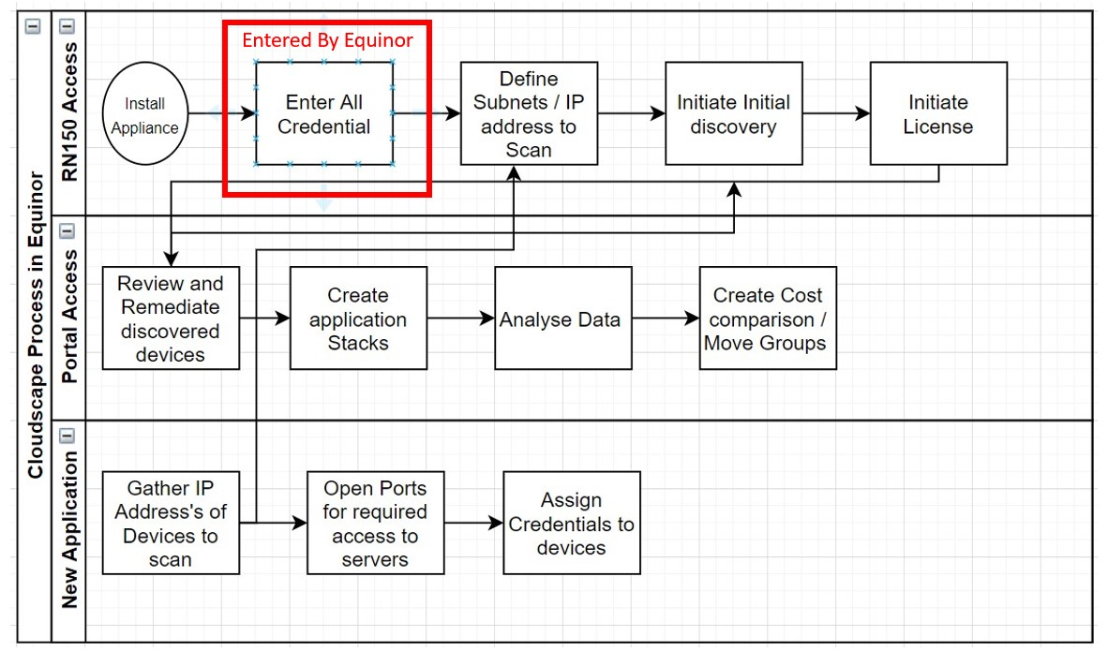

* Do you have a process for continuous improvement (e.g. by regular retrospectives)?

Process of how to use the software has been developed along with Security Team of Equinor (Lead by Morten Somby). The attached process flow chart has been finalized.



* Do the software developers have direct contact with the users of the software?

No, it is a vendor managed tool so there will be no direct contact.

* Do you have an automated CI/CD pipeline?

No

* Please describe (using keywords) how the software is being tested?

The testing has not been done as HCL has used Cloudscape Tool for performing assessment in other accounts since past 6-7 years so it is tried and tested in other accounts.

<https://cloudscape.net/about/>

* Do you have automated tests, run as part of your CI/CD pipeline?

No

* Have you assessed the technical debt in the software? How will you handle it?

Not Applicable.

* If your application contains a GUI, are you aligning your design with the [Equinor Design System](https://eds.equinor.com/)

No, the GUI is predefined

[**Data & Information Architecture**](https://acrepo.azurewebsites.net/#/template/ac_template?id=data-amp-information-architecture)

Note: See [this link](https://github.com/equinor/data-engineering/tree/master/docs) for optional related templates that can be linked to instead of commenting here.

* Is the full [lineage](https://en.wikipedia.org/wiki/Data_lineage) of data used by your application understood and how has this impacted your design choices?

Design is not impacted, just the way we use the application has changed according to the design choices.

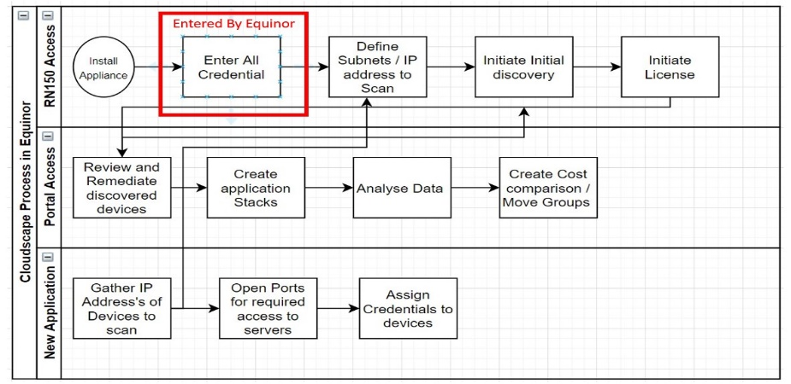

* How is the data flowing into your application?

Perform collection via WinRM and or SSH. Data is collected by the on-prem VM location and periodically exported, encrypted, and securely transmitted via TLS to the RISC Networks Secure Cloud Environment (SCE) which is the data repository for the engagement. The data is then accessed by browsing to [www.riscnetworks.com](http://www.riscnetworks.com) and logging in to the assessment portal.

<https://documentation.riscnetworks.com/overview/architecture%252C-data-handling%252C-and-security/>

* Must data be kept in sync with other applications (where the same or related data appears multiple places? If yes, how are they kept in sync (e.g. event-based, sync-based)

No

* Is data in your application immutable, i.e. data is never updated or deleted? Are there any special requirements, legal or otherwise, regarding retention?

Once this app is no longer used all data will be deleted. Raw customer assessment data is held in RISC Networks’ SCE for a period of up to 35 days past the subscription end date. After the subscription expires, the data is deleted completely.

* Is your application considered to be a "systems of records" for all or a subset of the data? i.e. It holds the source of truth and if there is a deviation with another system, the value in the system of record is by definition the correct one.

NO

* Is your application considered to be a "derived data system", i.e. data in your application is the result of taking some existing data from another system and transforming or processing it in some way. If you lose the derived data in your application, can you easily re-create from the original sources?

Yes, data can be recreated.

* Has a Legal Risk Assessment been performed? See [KB0042661](https://equinor.service-now.com/selfservice?id=kb_article&sys_id=96435887db360058c293199f299619c8) for more information.

Security Risk assessment and Vendor Risk Assessment has been performed by Matthew Smith.

 

* How will other applications consume data from your application?

No application will consume the data

* What data from your application will be shared in the enterprise data platform?

None

* Is any produced / shared data (whether in the data platform or not)
  + Aligned with the [Enterprise Data Architecture](https://docs.omnia.equinor.com/services/data/dataarchitecture/overview/) YES
  + Uses master & reference data NO
  + Discoverable (registered in Data Catalog, APIM) NO
  + Named / structured / modeled according to established international or national open standards? YES
* What data quality requirements are needed / assumed by your application and any consumers of data and how are these ensured and monitored. Requirements might be related to accuracy, consistency, completeness, integrity, timeliness and more.

No data QA required

* Have you evaluated how the application should handle personal data, with GDPR regulations in mind? This includes logging of information that can identify a person, like name name, userID, email, etc.

Yes, this is Compliant with GDPR requirements as it does not collect any personal data.

<https://documentation.riscnetworks.com/overview/architecture%252C-data-handling%252C-and-security/>

* Have you understood and agreed the service level objective for your data (availability, Recovery Time Objective (RTO) / Recovery Point Objective (RPO) etc.) and have you taken that into considering when making your storage technology choice?

Yes, all this has been incorporated into the design. Although RTO and RPO are not involved in this tool. A process flow chart has been finalized.



* If we want to exit the application, but keep data usable other places - how do you plan doing that?

Raw assessment data is held in RISC Networks’ SCE for a period of up to 35 days past the subscription end date. After the subscription expires, the data is deleted completely.

[**Security and information management**](https://acrepo.azurewebsites.net/#/template/ac_template?id=security-and-information-management)

* Who is the information owner for the software/application?

Equinor

* What is the classification of the information handled by the software (open, internal, restricted, confidential)?

Confidential

* Have you assessed how the information classification impact the security in the software?

Yes, Vendor adhere to strict regulatory compliance standards such as: PCI DSS Level 1, SAS 70 and ISO 27001b

<https://documentation.riscnetworks.com/overview/architecture%252C-data-handling%252C-and-security/>

* Development teams are responsible for initiating a [Security Health Check](https://statoilsrm.sharepoint.com/sites/Informationsecurityhealthcheck/Shared%20Documents/Forms/AllItems.aspx?RootFolder=/sites/Informationsecurityhealthcheck/Shared%20Documents/General&FolderCTID=0x012000D071A196DD4AD54E88B2352C5D9C5289). Has this been performed?

Security Health Check has been done.



* Will you (or have you) ordered a penetration test? A penetration test is recommended for applications handling confidential or personal data or in cases where the risk is particularly high.

Not required.

[**Operations**](https://acrepo.azurewebsites.net/#/template/ac_template?id=operations)

* Which team / department will have the operational responsibility for the software?

HCL COP Team/ IT-IAS-CS

* Has the RunBook been created?



* Has service design been done (LM of the department with operational responsibility is responsible)?

Done

<https://equinor.service-now.com/cmdb_ci_spkg.do?sys_id=f8a81a74db4e18d03f392a8cd396192e&sysparm_view=>

* Do you have any operational monitoring of the application?

Yes, can be monitored by browsing to [www.riscnetworks.com](http://www.riscnetworks.com) and logging in to the assessment portal and monitored by the HCL COP Team.

* What have you done to ensure reliability and resilience in the software?

It is not a business-critical tool/application. There is no impact on the business, so resilience may not be applicable (in the case of any issues, it can re-installed) and there is no impact to the business or to any other applications.

* What have you done to make it as easy and efficient as possible to operate the solution (reducing Total Cost of Ownership)?

Compared all the assessment tools available and assessed the compatibility of the tool with Equinor application portfolio

**For procured software:**

* What kind of support & maintenance agreement do you have with vendor (if procured software)?

8 business hour initial response on all severity levels except for Critical issues which will be responded within 4 business hours and maintenance support will be provided throughout the subscription period.

* How often will you get updates?

As per the Product feature releases by the vendor

<https://documentation.riscnetworks.com/using-the-platform/release-notes/>

* Is the vendor committed to follow the lifecycle on components they are depending on, such as Microsoft SQL server, Microsoft Windows etc.?

No dependency

[**Sharing is caring**](https://acrepo.azurewebsites.net/#/template/ac_template?id=sharing-is-caring)

* What do you plan to share from your project/initiative/solution/team/? with the Equinor Developer Community?

We will share or publish the reports and the results of the assessment done by Cloudscape Tool with the respective application owners and COP team members.